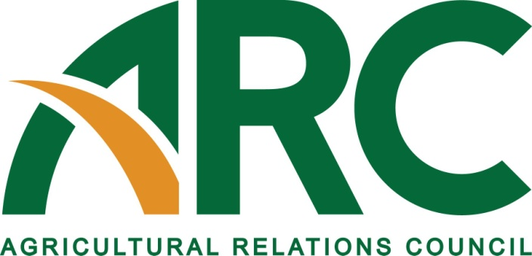

605 Columbus Ave. South, PO Box 156, New Prague, MN 56071 • 952-758-5811 • Fax: 952-758-5813
•http://www.agrelationscouncil.org •arc@gandgcomm.com

2014 MEMBERSHIP APPLICATION

The Agricultural Relations Council (ARC) is a national association, organized in 1953, of public relations professionals working in agriculture, food, fiber and related industries. ARC provides a medium for the exchange of ideas, professional development, and a closer working relationship among those involved in public relations in the food and fiber industry. Membership in ARC provides the opportunity to learn about the food and fiber industry and public relations as a profession. Membership benefits include an annual meeting, seminars and workshops, networking opportunities at allied organization meetings, ARCLight - a membership newsletter and professional recognition opportunities. News and other information are also provided through the ARC website located at http://www.agrelationscouncil.org.

Applicant Information

Name: Title:

My contact information has not changed. Please use last year’s information.
X_

Do you have an APR designation? Yes No
X_
X_

Company: If student, what university?

Describe Your Present Job Duties:

Address:

City, State, Zip:

Work phone: Fax:

Cell: Twitter Address (optional):

E-mail: Web site:

How did you find out about ARC?

List organizations you belong to:

Please list education and professional experiences:

I would be interested in working on a committee: Yes No
Membership Accreditation Hall of Fame
Annual Meeting Contests Futures

Membership Dues
This is a MEMBERSHIP RENEWAL
X_
This is a NEW MEMBERSHIP
X_

□ Renewing ARC Member
First member joining from a company -- $190*
Second member and each add’l joining from the same company -- $115*

□ New ARC Member (no one else from your company is a member) $190*

□ Student $25
TOTAL DUES
*A fully tax-deductible contribution of $15 is included for the ARC Foundation that will assist ag PR students in
industry-related professional development. If you prefer not to contribute, please notify the ARC office at 952-758-5811.

Please check the method of payment:
Check Enclosed (made payable to Agricultural Relations Council)
X_
Credit Card Card Type: MasterCard Visa American Express
X_
Card Number:
Expiration Date
Signature:

Billing/Mailing Address of Credit Card if different from first page:

*Completed membership forms may be emailed to arc@gandgcomm.com, faxed to 952-758-5813 or mailed with payment to the address below.

Return this completed application with your payment (if applicable) to:
Agricultural Relations Council
605 Columbus Ave. S.
PO Box 156
New Prague, MN 56071

Gear Up With ARC!
You’re probably already aware of challenges in agricultural public relations today. The Agricultural Relations Council (ARC) can help you gear up to meet those challenges. ARC is the only association dedicated specifically to serving the unique needs of public relations professionals working in agriculture, food, fiber and other related industries. ARC is a conduit for problem-solving, idea-sharing and collaboration among members, who share a passion for excellence in agricultural public relations.

Who Joins ARC?
Anyone involved with agricultural public relations interested in professional development joins ARC. Members work for agricultural and food companies, PR and marketing firms specializing in agriculture, associations, governmental bodies and other organizations.

What is the purpose of ARC?
We are organized, as outlined in the bylaws, “To promote the common good through advancement of the art, science and practice of public relations in agriculture.”

When does the organization meet?
ARC’s annual business meeting and professional development workshop is held each March in a different location around the country. The organization also meets at times informally at the Ag Media Summit (AMS) in the summer. Webinars and other professional improvement efforts are also undertaken each year.

Where are ARC members located?
The ARC membership is scattered across the United States. Members occasionally sponsor local and regional functions for ARC members in their area.

Why join ARC?
Through interaction with your peers, you can broaden your knowledge of agriculture and the latest PR strategies and techniques. ARC is the only organization that focuses on the special interests of agricultural public relations practitioners. ARC membership also entitles you to the following benefits:

- Golden ARC Awards – see how your ag PR work stacks up against that of your peers.
- The ARC website. http://www.agrelationscouncil.org/
- ARCLight On-Line Newsletter – industry happenings, organization and member news, industry hot topics, professional development tips and more delivered to your e-mail inbox.
- Founders’ Award – a coveted award recognizing one public relations professional for excellence in the industry.
- Hall of Fame – recognizing ARC members for lifetime service.
- Student Membership – allows future agricultural public relations professionals to enjoy the benefits of ARC membership at a reduced dues rate.
- Membership discounts also are available to firms and organizations that sponsor multiple members.

How does ARC collaborate with other ag communications groups?
The Ag Relations Council believes collaborations are important for professional development for its members. It is pleased to be assisting the National Agri-Marketing Association in planning workshops for its annual spring conference. It also works with the Ag Media Summit each year sponsoring a silent auction, with proceeds assisting college students.

How do I join?
You have to be a practicing public relations professional to belong to ARC. Your membership application will be reviewed prior to granting membership. You will find an application online at www.agrelationscouncil.org. You can fill out the membership application and email to: arc@gandgcomm.com OR mail with payment to: ARC, 605 Columbus Ave. S, PO Box 156, New Prague, MN 56071.

