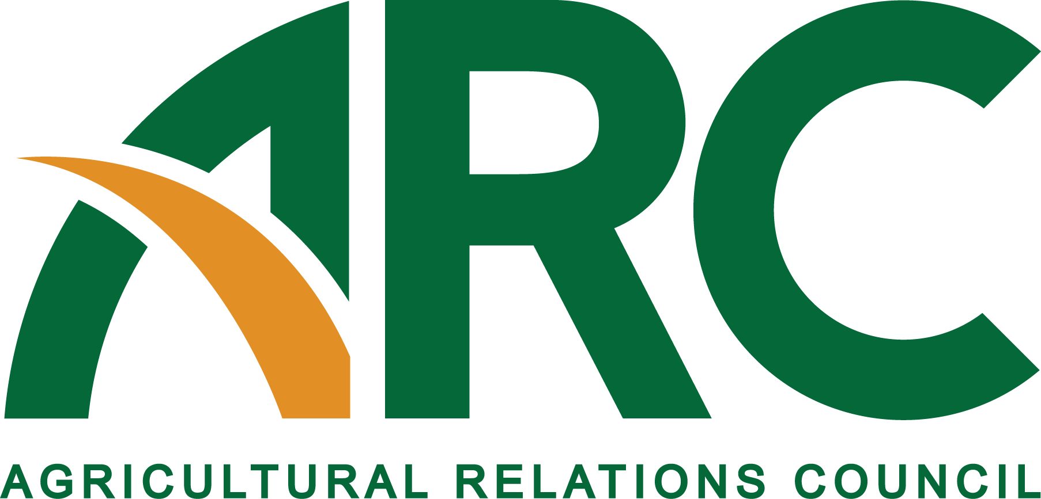
605 Columbus Avenue SE., PO Box 156, New Prague, MN 56071 • 952-758-5811 • Fax: 952-758-5813 •www.agrelationscouncil.org•

2016 Agricultural Public Relations Hall of Fame
Sponsored by Agricultural Relations Council and
Agri Marketing magazine

The next group of inductees to the Agricultural Public Relations Hall of Fame will be announced on June 25, 2016, at the organization’s annual meeting in St. Paul, MN. The award is sponsored by the Agricultural Relations Council (ARC)
and Agri Marketing magazine.

Deadline for entry: March 15, 2016

CRITERIA FOR NOMINATION

Following is the criteria to be considered for the Agricultural Public Relations Hall of Fame. This award will be given annually to agricultural public relations professionals who have made lifetime contributions to the industry. Nominees must be a current or past member of ARC to be considered.

Nominees will be selected based on criteria including:
- Years of membership in ARC;
- Service to ARC (president, board member, committee chair, etc.);
- Professional accomplishments/achievements in ag communications; and
- Awards/Recognition in service to ag communications within ARC and also outside of the organization.

For 2016, nominations will be reviewed and inductees chosen by a committee of ARC members.

2016 Agricultural Public Relations
Hall of Fame Award Application Form

Date

(If person listed is nominated posthumously, please provide a family member’s contact information as appropriate and available.)

Name of Nominee

Address of Nominee

Phone of Nominee (office or home) Phone (cell)

E-Mail of Nominee

(Nominee will be notified ONLY if selected for induction.)

Person Making Nomination

Phone (office) Phone (cell)

E-Mail

Please include the following in your application packet:
- Application Form.
- Letters of recommendation from two references.
- Essay (500 words or less which describe why this person should be considered for entry into the Agricultural Public Relations Hall of Fame.)
- Other supporting documentation as appropriate.

This application deadline is March 15, 2016. Application packets may be submitted by mail, e-mail (arc@gandgcomm.com) or fax (952/758-5813). Mail to:
Den Gardner, Executive Director
ARC
PO Box 156
New Prague, MN 56071

For more information, call Den Gardner at the ARC office at 952/758-5811.

