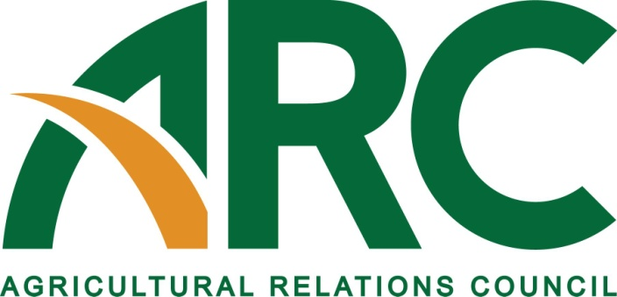

605 Columbus Ave. South, PO Box 156, New Prague, MN 56071 • 952-758-5811 • Fax: 952-758-5813
• www.agrelationscouncil.org • arc@gandgcomm.com

2018 MEMBERSHIP APPLICATION

The Agricultural Relations Council (ARC) is a national association, organized in 1953, of public relations professionals working in agriculture, food, fiber and related industries. Membership in ARC provides the opportunity to learn about the food and fiber industry and public relations as a profession. Membership benefits include an annual meeting, seminars and workshops, networking opportunities at allied organization meetings, ARCLight - a membership newsletter, a college scholarship and internship program and professional recognition opportunities.

Applicant Information

Name: Title:

My contact information has not changed. Please use last year’s information.
X_

Do you have an APR designation? Yes No
X_
X_

Company: If student, what university?

Describe Your Present Job Title:

Address:

City, State, Zip:

Work phone: Fax:

Cell: Twitter Address (optional):

Email: Website:

How did you find out about ARC?

List organizations you belong to:

I would be interested in working on a committee: Yes No
Membership Accreditation Hall of Fame
Annual Meeting Contests Futures (Scholarship/Internship)

Membership Dues
This is a MEMBERSHIP RENEWAL
X_
This is a NEW MEMBERSHIP
X_

□ Renewing ARC Member
First member joining from a company -- $190*
Second member and each addt’l joining from the same company -- $115*
Third member from the same company – If age 35 or younger -- FREE

□ Farm Bureau Federation or Commodity Group Member (state and federal) $100* _________
Second member and each addt’l joining from the same company -- $100*
Third member from the same company – If age 35 or younger -- FREE

□ New ARC Member (no one else from your company is a member) $190*
Second member and each addt’l joining from the same company -- $115*
Third member from the same company – If age 35 or younger -- FREE

□ Student $25
TOTAL DUES
*A fully tax-deductible contribution of $15 is included for the ARC Foundation that will assist ag PR students in
industry-related professional development. If you prefer not to contribute, please notify the ARC office at 952-758-5811.

Please check the method of payment:
Check Enclosed (made payable to Agricultural Relations Council)
X_
Credit Card (select one) MasterCard Visa American Express
X_
Name on card:
Card Number:
Expiration Date:
Security Code:
Signature:

Billing/Mailing Address of Credit Card if different from first page:

*Completed membership forms may be emailed to arc@gandgcomm.com, faxed to 952-758-5813 or mailed with payment to the address below.

Return this completed application with your payment (if applicable) to:
Agricultural Relations Council
605 Columbus Ave. S.
PO Box 156
New Prague, MN 56071

