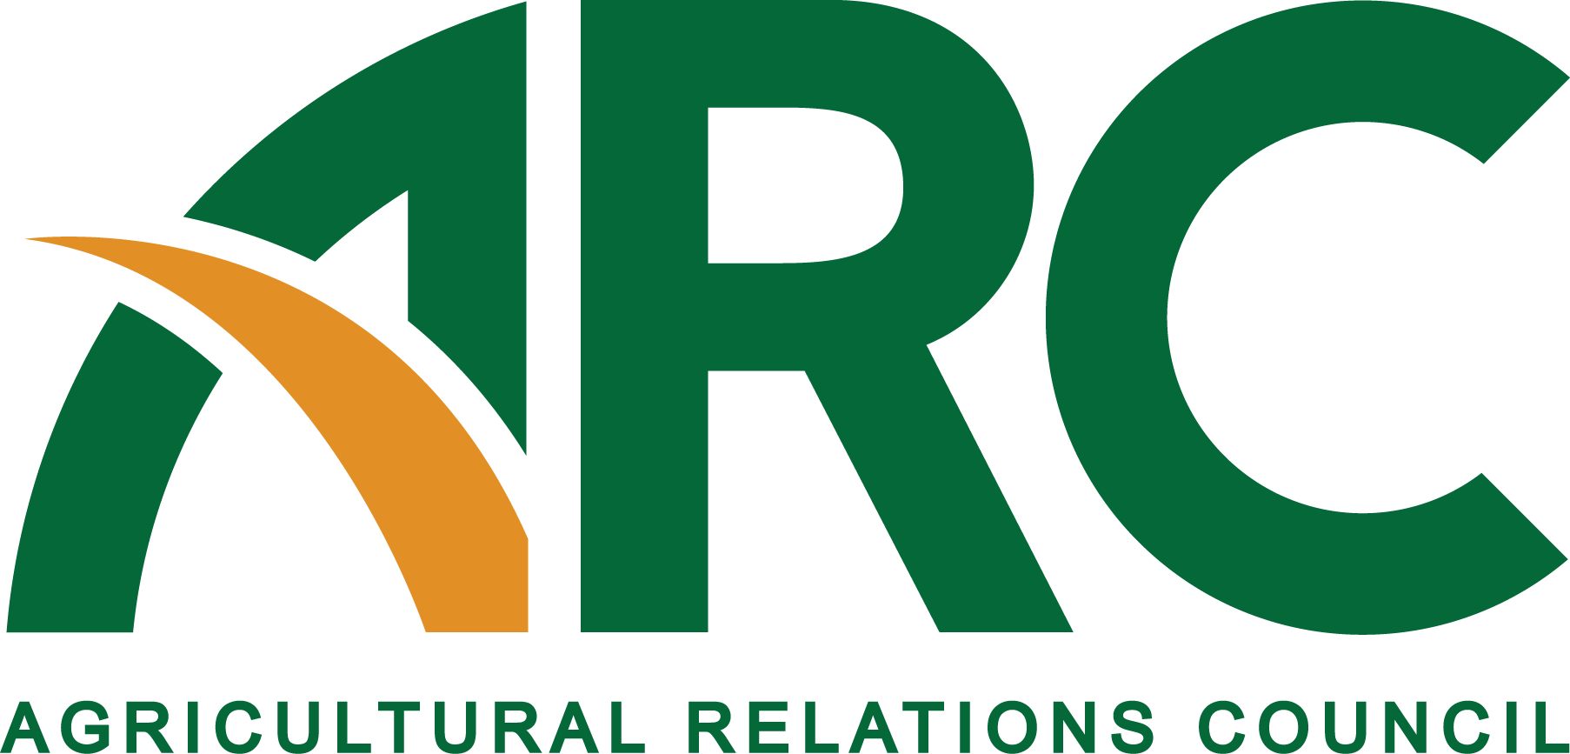

605 Columbus Ave. South, PO Box 156, New Prague, MN 56071 • 952-758-5811 • Fax: 952-758-5813 www.agrelationscouncil.org • arc@gandgcomm.com
FOR IMMEDIATE RELEASE
For More Information: Den Gardner, 952/758-5811
arc@gandgcomm.com
Alltech Selected to Host ARC Intern

December 29, 2016 (NEW PRAGUE, Minn.) – The Agricultural Relations Council (ARC) is pleased to announce Alltech, one of the top five global animal health and nutrition companies, has been chosen to host the ARC intern in the spring and summer of this new year.
ARC member Susanna Elliott of Alltech plans, among other traditional duties, to utilize the intern to assist with communications efforts surrounding its ONE: Alltech Ideas Conference, an event that attracts more than 3,000 leaders in agriculture from nearly 70 countries.

“We plan to have the intern write press releases, blogs, articles and social media posts,” Elliott says. “Alltech is a strong supporter of ag-related education. We are thrilled to host the intern.”
The internship is unique in ag communications in that it is a collaboration of the organization (ARC) and the company (Alltech). The ARC portion of the funding comes from a grant from Gardner & Gardner Communications. ARC will coordinate the internship program and selection.
“The ARC Foundation is excited to re-energize and re-introduce our internship program,” says Executive Director Den Gardner. “The board is committed to creating a first class internship program and know that the folks at Alltech will represent our organization well in this endeavor. Now it’s on to the internship application process.” Student applications open Feb. 1.
ARC will use Ag Communicators of Tomorrow (ACT) chapters and NAMA student chapters, among other efforts, to publicize and search for potential interns among the college ranks. The intern will be based in Nicholasville, KY. The student will be chosen in April.
###

